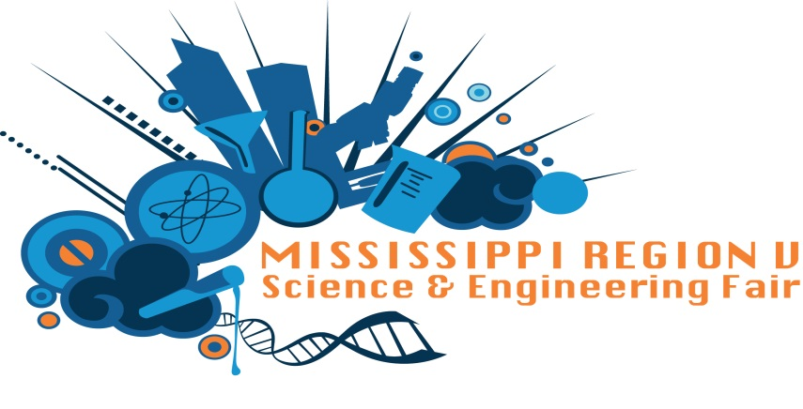

2017 Region V MSEF Winners for 1st Grade

Best of Fair
Griffin Winstead

Category Awards

Behavioral and Social Sciences
1st place Harrison Routzahn
Biochemistry
1st place Logan Lang 4th place Connor Anderson
2nd place Jeremiah Jackson 5th place Cameron Gribson
3rd place Maggie Wright
Inorganic Chemistry
1st place Jake Macasek 3rd place Kabriah Sims
2nd place Rylie Meely 4th place Aymeri McMillian
Organic Chemistry
1st place Johnathan Patrick
Earth and Environmental Science
1st place Bailey Hardy
Animal Science
1st place Konley Anderson
Medicine and Health
1st place Guy Rawson
Microbiology
1st place Jackson Ward
Physics and Astronomy
1st place Griffin Winstead 4th place Mariia Tsvetkora
2nd place Cameron Brewer 5th place Nikolas Zingler
3rd place Nora Peterson
Engineering
1st place Asher Dewease 3rd place Nolan Richardson
2nd place Jack Alawine 4th place Sherman Billy Jr.
Computer Science and Math
1st place Jazmine Lewis
Botany
1st place Rylee Goforth 3rd place Aizlynne Hindly
2nd place Stella Burroughs 4th place Amee Stell

