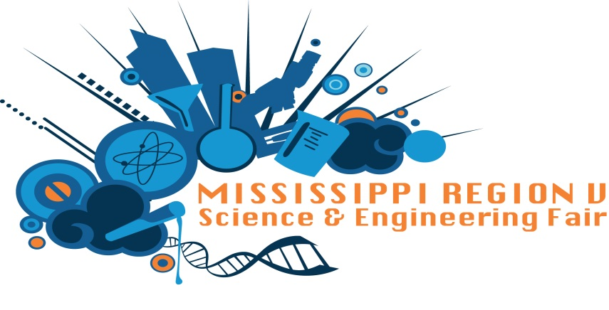

2017 Region V MSEF Winners for Kindergarten

Best of Fair
Logan and Eli Eldeman

Category Awards
Biochemistry
1st place |  | Ian Gonzalez
2nd place |  | Maddox Minor
3rd place |  | Logan and Eli Edelman
4th place |  | Kaecetyn Williams
Inorganic Chemistry
1st place |  | Seth Hollingsworth
2nd place |  | Jaqualon Smith
3rd place |  | Zamiah Stepp
Organic Chemistry
1st place |  | Lindsey Leake
Earth and Environmental Science
1st place |  | Bennie Winstead
Animal Sciences
1st place |  | Gracie Wiggins
Engineering
1st place |  | Christian Townsend and Mekhi Bush
Computer Science and Math
1st place Hunter McMillian
2nd place Justin Rupert
Robotics and Intelligent Design
1st place Leim McMillian

