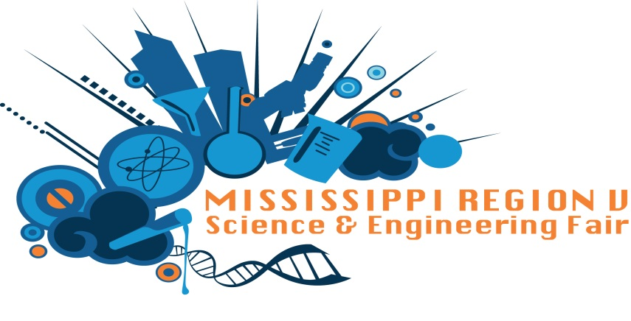
2017 Region V MSEF Category Winners for Class 3
7th and 8th Grade
Best of Fair
Hannah Boyette: Northeast Lauderdale Middle

Behavior and Social Science
1st Place Shruti Patel
2nd Place Gabe Templeton
3rd Place Clair Sullivan
Biochemistry
1st Place Sydney Holt
2nd Place Destiny Jones
3rd Place Braden Walters
Inorganic Chemistry
1st Place Zach Holliman
2nd Place Wonjae Cho
3rd Place Caitlyn Ryan
Organic Chemistry
1st Place Macy Campbell
2nd Place Clara Halsey
3rd Place Brianna Riordan

Earth and Environmental Sciences
1st Place Reid Fishel
2nd Place Luca Hoffmann-Meyer
3rd Place Demidrea Stokes
Animal Sciences
1st Place Zeke Pulido
2nd Place Laura Kate Robinson
3rd Place Emma Kate Sowell
Medicine and Health
1st Place Hannah Boyette
2nd Place Cora Gibson
3rd Place Alyssa Farmer
Microbiology
1st Place MaKayla Hickman
2nd Place Brianna Mattox
3rd Place Amelia Hurt
Physics and Astronomy
1st Place Vivek Nagarajan
2nd Place Gordon Welch
3rd Place Micah Zellner
Engineering
1st Place Lauren Jensen
2nd Place Britney raley
3rd Place Barrett Harwell
Computers and Math
1st Place Chloe Belue
2nd Place Logan Hazzard
Robotics and Intelligent Design
1st Place Memoire Willis & Annie Isaac
Botany
1st Place Andrew Woody
2nd Place Abigail Krutz
3rd Place Kamaria Smith

