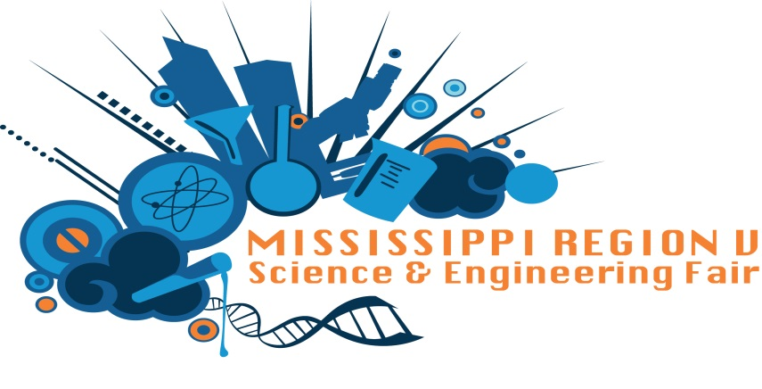
There are multitudes of benefits for students who participate in High School Science Fairs not only for themselves, but for communities and future workforce as well.
Did you know that students can win awards, medals and ribbons totaling more than $5,000 as well as scholarships at the regional fair and have the opportunity to compete at the state level for additional awards?
Winners from regional and state competition also have the opportunity to compete in other scientific research competitions such as Broadcom Masters (middle school program), iSWEEEP (sustainability competition) and advance to the Intel ISEF?
A recent research study (Sahin, 2013) indicated that students who participated in science and engineering fairs at the high school level had a 100 % graduation rate, an 88% matriculation to a 4-year college of which 67% chose STEM fields.
Participants who advance to the Intel ISEF are among the best and brightest as they develop skills that ultimately transfer into making scientists, teachers, inventors, engineers, and entrepreneurs for our future workforce.

