Science Fair “the process”

This is what you are aiming for (STEP 11)
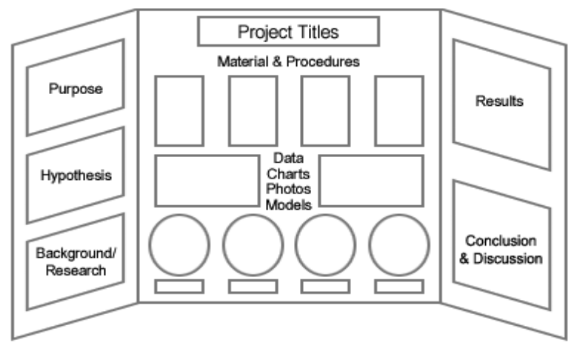

STEP 1
Topic/Question:
When you chose your topic you should form a question about your research. Make sure it is original and not copied from a website.
What is the question you want to investigate?
____________________________________________________________________________________________________________________________________________________________________________________________________________________________________________________________________________________________________________________________________________________
Why do you want to investigate it?
____________________________________________________________________________________________________________________________________________________________________________________________________________________________________________________________________________________________________________________________________________________

STEP 2
Title:
The title should be catchy (remember it will go on the board). Start with “A study of…” or “An investigation of…” Or restate your question you want to answer in a fun way.
What is your title?
_______________________________________________________________________________________________________________________________________________________________________________________________________________________________________________________________

STEP 3
Hypothesis:
This is a testable statement:
An Example of How to Write a Hypothesis
A worker on a fish-farm notices that his trout seem to have more fish lice in the summer, when the water levels are low, and wants to find out why. His research leads him to believe that the amount of oxygen is the reason - fish that are oxygen stressed tend to be more susceptible to disease and parasites.
He proposes a general hypothesis. “Water levels affect the amount of lice suffered by rainbow trout.”
This is a good general hypothesis, but it gives no guide to how to design the research or experiment. The hypothesis must be refined to give a little direction. “Rainbow trout suffer more lice when water levels are low.”
Now there is some directionality, but the hypothesis is not really testable, so the final stage is to design an experiment around which research can be designed, a testable hypothesis. “Rainbow trout suffer more lice in low water conditions because there is less oxygen in the water.”

What is your hypothesis?
____________________________________________________________________________________________________________________________________________________________________________________________________________________________________________________________________________________________________________________________________________________

STEP 4
Experimental Design:
Materials:
Keep a log (outline form) of ALL of the materials you use in your project. You may even want to take pictures of some of the interesting, less common materials.
What are your materials? You can always add to this!
1.
2.
3.
4.
5…..

Procedure:
This is the method or steps that you take to do your research.
You must write and explain everything you do specifically. You should be able to hand your procedure to someone who knows nothing about your research and they should be able to completely reproduce your research investigation. Include any surveys or interview questions you will use separately.
It is best to write this in outline form and you can always revise it.
What is your initial procedure? (You will revise this and keep it as you do your project)
1.
2.
3.
4.
5.
6.
7.
8.
9.
10….

STEP 5
Background research:
You have to write a research plan. Include (1) information about topic (2) hypothesis and/or research questions, (3) Materials needed, (4) Procedure for your study, (5) Any important information you need for human, animal or potentially hazardous projects *I will help with this. *Include 1-4 in your first draft.
This is a paper that ranges from 3-5 pages. (not counting title page and works cited page).
FIRST
Find AT LEAST 5 sources about your science fair topic. DO NOT USE WEBSITES or BLOGS!!! Some common links and sources are below.
http://eric.ed.gov/ (EMCC should have a password if needed) Ask your English teacher
Go to the Library!
Any Book!
Use Google Scholar to find journals and articles!
Use your information from where you got the idea for the project it will usually have other places you can go find information.
Look up words you do not know and use those sources.
For each source write all of the interesting facts you find on one side of a notecard (or paper) and write the citation on the other side. For JOURNAL ARTICLES your citation should follow the following format.
1st Author last name, first initial. middle initial., 2nd Author last name, first initial. middle initial., & 3rd Author last name, first initial. middle initial. (Year). Title of article all lowercase except first letter. Title of Journal or Periodical, volume number(issue number), pages. url link to find article if found online.
You can find other forms of citations (books etc.) using the following website.
https://owl.english.purdue.edu/owl/resource/560/01/
If you do a good job on this step then writing the research plan will be very easy. You will already have facts to write about and your reference page will be ready to type.
SECOND
Write your research plan (3-5 pages), double spaced, times new roman 12 point font, include a title page and works cited page.
You will write a draft and email it to me. I will proofread and send back for you to make corrections then ideally this step will be over.
Title page includes at least your name and title.
Works cited:
Include all internet sites (not google not science buddies these are search engines) needs to be the specific site.
Include books, magazines, people (interviews)
For help see:
http://www.sciencebuddies.org/science-fair-projects/project_bibliography.shtml
or
https://owl.english.purdue.edu/owl/resource/560/01/
This will go at the end of your paper and on your board.

STEP 6
Forms:
All forms are different depending on projects. We will discuss this later. They MUST be filled out before you begin your project. Visit the forms wizard on the website sciencefair.msstate.edu for help.
Also choose a category at this time.
STEP 7
The Project
After the research summary and forms are submitted and approve you can begin the fun! Follow your procedures in the research summary. Keep information in a Log Book.
STEP 8
Results/Data:
You will need to collect data and represent it using graphs and tables.
Results/Discussion:
This is the data (your charts and graphs) written in paragraph form.
These are NOT and opinion. Just simple state your findings.
- Use complete sentences
- Use average or number results
- Discuss what the numbers in the data mean
- Describe anything that is interesting. What are the “WOW factors”
- Be short and sweet and to the point.

STEP 9
Conclusion:
This is a summary of your investigation.
STEP 10
Abstract:
Visit the website sciencefair.msstate.edu for more information.
STEP 11
The board: (See first page of packet)
You can use a tri-fold board or make a poster and print it. If you make a poster you will be responsible for the costs for printing.

Things to keep in mind:
- Use the metric system (cm, m, g…) not inches, feet, miles, pounds.
- When you create tables and graphs for your board you have to cite them. Simply say “This table was created by John Brown using Microsoft Word.”
- If you include pictures you must cite them. Simply say “This picture was taken by John Brown using an iPhone 5.
- DO NOT include faces in your pictures you will be disqualified!!!!
- You cannot have any food on the board.
- Keep a composition notebook filled with what you do every time you work on your investigation. Loose leaf paper is not recommended.
- For more information on any of the steps in this packet, please see the website resources page.
- Website: sciencefiar@msstate.edu

