The Science Fair Board
Suggestions and
Restrictions

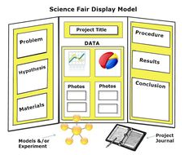

Suggestions
- Take pictures to display on the board or in a journal.
- Use software (Excel) to make chart, graphs and other visuals.
- If you use pictures or graphs you must cite them. If you take the pictures or make the graphs you should include “pictures/graphs taken/generated by name using device/software name. Cite EVERYTHING
- Make copies of your abstract to hand out.
- Display your journal for judges.

Restrictions
- No abstract on the board
- No pictures of human faces
- No food or liquids including: candy, water, packets containing sugar, yeast, candy, etc. (you can empty them and use them).
- No live organisms
- No chemicals/biological agents (including water)
- For further questions contact MSEF Region V director msefregionv@gmail.com

Examples
Board
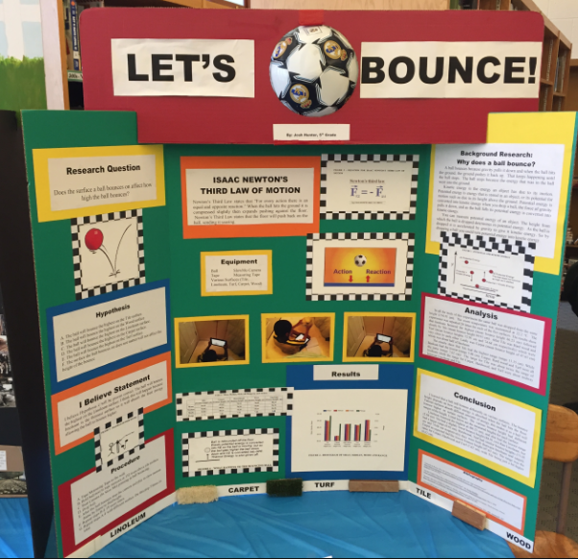

Board
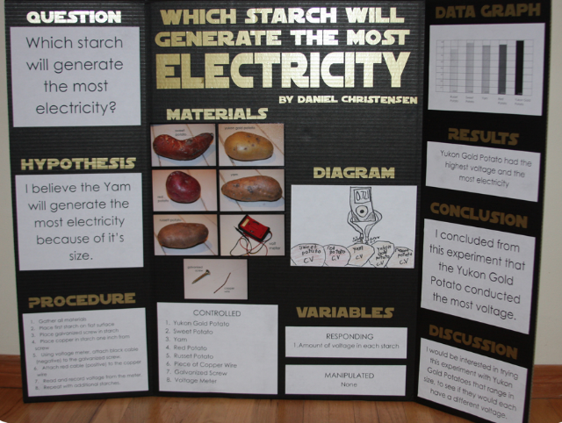

Poster
