2026 Mississippi Science & Engineering Fair (MSEF): State Level

The 2026 State Level MSEF will be hosted on April 9, 2026 at Northeast MS Community College, Boonville in the Bonner Arnold Coliseum.

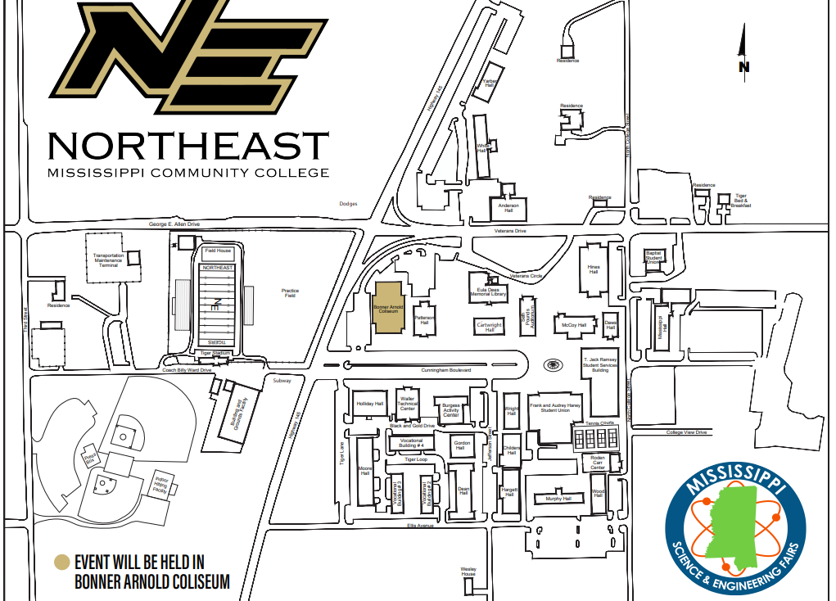

Region V MSEF participants who place 1st, 2nd, or 3rd, in their category in grades 7-12 will advance to the State Level competition.

The Regional Fair Director will communicate registration with the State Fair Director. Then information will be provided to all advancing participants.

If you have questions, contact 662-325-1360 | sciencefair.msstate@gmail.com

