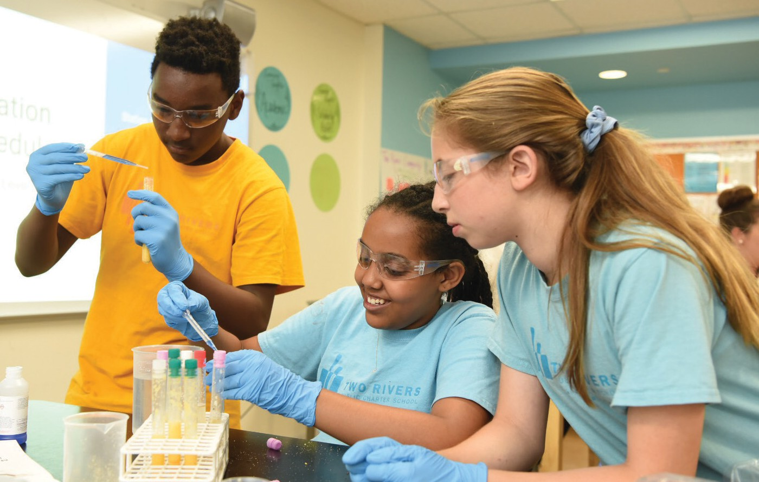ADVOCATE PROGRAM
This program provides a $3,000 stipend and in-person training to an individual (teacher, counselor, mentor) who agrees to serve as an advocate for 3–5 additional underserved students to transition them from conducting a scientific or engineering research project to completing applications to scientific research competition(s). Advocates support students in finding potential research competitions, being aware of deadlines,
gathering information needed for the applications, and navigat- ing the overall science research competition process.
SIGN UP ONLINE TO BE NOTIFIED
WHEN THE NEXT APPLICATION OPENS:
www.societyforscience.org/outreach-and-equity/advocate-program/

HIGH SCHOOL RESEARCH TEACHERS CONFERENCE
This annual conference brings 200 high school science research teachers from across the country to Washington, D.C., for an all-expenses-paid weekend of sharing best prac- tices, trouble-shooting challenges, and developing a support network for teachers who lead students in scientific research. Equal numbers of veteran, intermediate, and novice research teachers are selected, with preference given to schools that have not had a teacher attend in the past.
SIGN UP ONLINE TO EXPRESS INTEREST: www.societyforscience.org/outreach-and-equity/ high-school-research-teachers-conference/

MIDDLE SCHOOL RESEARCH TEACHERS CONFERENCE
This annual conference offers a weekend of professional development to 50 middle school teachers, all-expenses-paid, in Washington, D.C. Middle school teachers from across the country meet to learn about topics related to leading students in science fair-type projects. Peer-led sessions focus on topics such as how to help students come up with questions that can be investigated with few resources and how to keep students safe while conducting experiments. Equal proportions of veteran, intermediate, and novice teachers are selected via lottery to attend, with preference given to schools that have not had attendees in the past.
TO LEARN MORE: www.societyforscience.org/outreach-and-equity/ middle-school-research-teachers-conference/

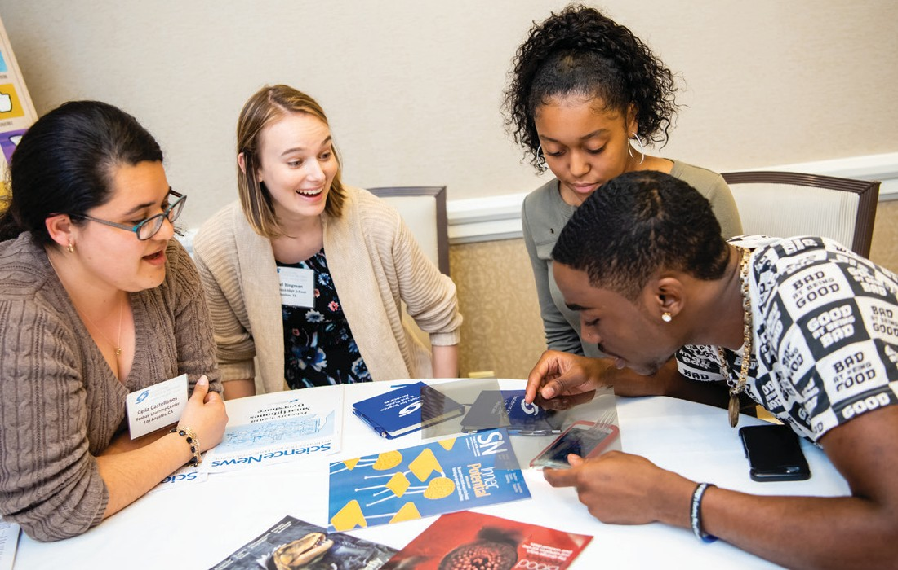SCIENCE NEWS IN HIGH SCHOOLS
This program brings Science News magazine, along with edu- cational resources, to high schools across the United States and worldwide. Teachers and students are offered access to the latest in-depth reporting on science topics, which provides them with real-world examples, information, and inspiration to transform how they interact with science in the classroom. A supplementary digital Educator Guide provides ready-to-use teaching content and lesson ideas for each issue of Science News during the program year.
SIGN UP ONLINE TO EXPRESS INTEREST IN YOUR SCHOOL BEING SPONSORED:
www.societyforscience.org/outreach-and-equity/
science-news-in-high-schools

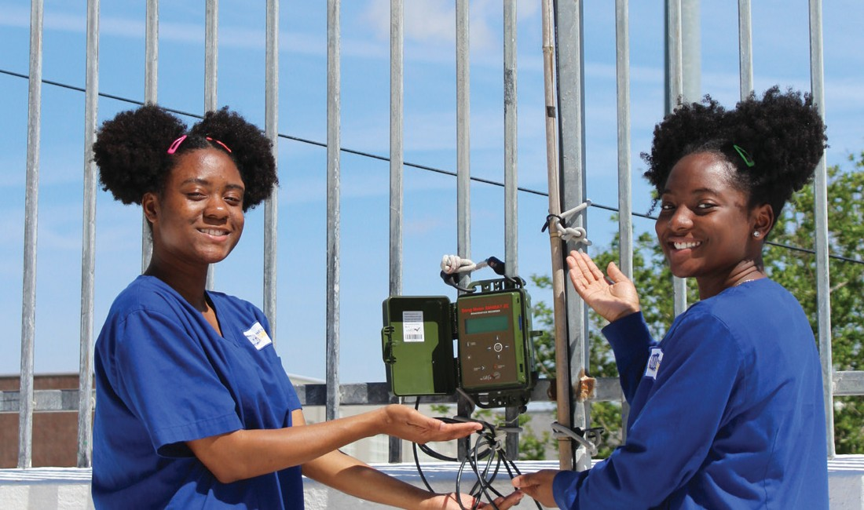STEM RESEARCH GRANTS
STEM Research Grants are offered to STEM research teach- ers for the purchase of equipment to be used in independent student STEM research projects. Eligibility to apply is typically dependent upon involvement in other Society programs; those eligible will receive email notification. The Society awards in- dividual grants of up to $5,000, totaling over $120,000 each year. Previous recipients have purchased equipment such as small wind tunnels, aquaponics equipment, or basic chemistry glassware.
SIGN UP ONLINE TO EXPRESS INTEREST: www.societyforscience.org/outreach-and-equity/ stem-research-grants

STEM ACTION GRANTS
STEM Action Grants are offered to innovative grassroots non- profit organizations that are working to enhance the public’s understanding of science and to increase participation of un- derrepresented populations in STEM fields through unique programming. Eligible non-profits may apply for a STEM Action Grant of up to $5,000. Previous grants have helped create mo- bile laboratories in rural communities, translate STEM lesson plans into Spanish, support diving field trips for underrepre- sented populations, and more.
SIGN UP ONLINE TO EXPRESS INTEREST:
www.societyforscience.org/outreach-and-equity/stem-action-grants

